Challenges faced by Silicon Photonics based Biosensing

Yash Chopra
Department of Electrical and computer Engineering
Colorado State University
Fort Collins, Colorado
yashc@colostate.edu
Mihir Pakhale
Department of Electrical and computer Engineering
Colorado State University
Fort Collins, Colorado
mihir20@colostate.edu

Sumant Sakhalkar
Department of Electrical and computer Engineering
Colorado State University
Fort Collins, Colorado
sumant24@colostate.edu

Abstract—The need to analyze and detect biological elements, related to human and environment health, in a fast and reliable way, is one of the major challenges faced by humanity at the dawn of the 21st century. In the last two decades, we have observed a remarkable progress in the development of bio sensing devices and their application in areas such as environmental monitoring, biotechnology, and medical diagnostics. For most of the applications, it is necessary to have a biosensor with high sensitivity, fast response, and able to perform real-time measurements. These requirements can be achieved using photonic Biosensors. Although these modules face a variety of challenges. We review and analyze the most important challenges faced by silicon-based optical biosensors such as the need for simulation tools and models and problem faced by Lab-on-Chip architectures.
Keywords—Photonics, Biosensors, Interferometer, MZI, MRR, resonator, Waveguide, Lab-on-Chip, Photonic crystal.

Introduction
Medical diagnostics and healthcare delivery are of major importance in the current scenario. Bio-sensors were introduced just to tackle this issue. When intruded by a disease-causing virus or bacteria, the body releases biomolecules called antibodies into the blood stream. The antibodies get attached selectively to a part of the antigen, to label it for attack by the immune system [1]. Accurate disease diagnosis should be performed and requires the measurement of the concentration of these antibodies. The concentration is as low as a few ng/ml, and there are other biomolecules in blood of much higher concentration (mg/ml). By attaching this antigen on a biosensor surface, the attachment of antibodies can be measured with high selectivity. Although the biosensors operating in electrical domain suffer from a lot of performance issues such as time consumption, cost and size [2]. Silicon photonics is a new emerging technology that shows promise for biosensing applications. It can provide selective quantitative analytical information using a biological recognition element which is in direct contact with a transducer element [6]. Silicon photonic biosensors based on evanescent wave detection have been considered as the most promising candidates for achieving truly point-of-care devices (As infrared light propagates through Nano-scale silicon wires on the chip, a part of the light’s electric field crosses the waveguide boundary and is sensitive to refractive index changes in the cladding and is called evanescent field) [10]. Pros such as miniaturization, extreme sensitivity, robustness, reliability, potential for multiplexing and mass production at low cost can be offered by these sensors [7].
Comparing these sensors to the state-of-the-art microelectromechanical (MEMS) sensor it was observed that photonic sensors can achieve sensitivity ranges of ≈10 ng/mL and detection limits almost similar to the electro-mechanical counterpart [3]. Also, silicon photonic devices are not susceptible to mechanical strain under normal microfluidic flow, electromagnetic interference, nor the electrical conduction issue of the analyte media. Additionally, these photonic biosensors offer the benefit of real-time monitoring of kinetic binding interactions [9].
We are focusing our energy in finding the reason for the SOI based biosensors not being commercially available and target to overcome this challenge. The need for simulation models and tools is inevitable and we intend to put our focus in tackling this issue.

Related Work
Photonic biosensors have a lot of advantages although they have not been used on a large-scale commercial use. This section discusses the previous work that has been researched for the same topic.
Several papers discuss the challenges faced by these sensors. Adrián Fernández Gavela et al. discussed the advances in silicon based optical Biosensors such as Interferometric Biosensors, Ring-resonator based biosensors and photonic crystal-based Biosensors [4]. They found out that the major challenge faced by all these types usually dealt with light uncoupling and the read-out process, the delivery and disposal of the sample, the bio-functionalization of the sensor surface, the necessity to ensure an adequate time period of useful life as well as handling limitations such as storing and temperature and humidity valid ranges. Individually, these types witness a few other problems. The main downside of ring resonator devices is the need to employ a tunable laser to excite the cavity resonance whereas for MZI based biosensors the nature of output signal has a complex interferometric nature.
One cause of major concern is the lack of availability of simulation tools and simulation models for liquid analyte testing for photonic biosensors. This is one of the most important issues. Since, photonic bio sensing is a new topic, not a lot of research and exploration was done in this field. This remains the leading reason for not using photonic biosensors for commercial use.
Another issue is the temperature dependency of effective index in SOI [5]. Since, the refractive index of these sensors are highly temperature-dependent, external heaters or coolers are often used to stabilize the temperature of the chip adding to costs. The need for active temperature control adds additional size and complexity to the sensor.
As mentioned earlier, photonic sensors can achieve sensitivity ranges of ≈10 ng/mL and detection limits almost similar to the electro-mechanical counterpart however these ranges cannot be achieved if secondary amplification is not done [8]. Also, for certain specific antigen such as prostate-specific antigen (PSA) the diagnostic level of significance is about 4ng/mL which creates a problem in analyzing the antigen [4].
The need for analysis of the existing commercial Lab-On-Chip architectures was inevitable to help determine the cause of Silicon based biosensors not being enough commercialized.

The Maverick detection System by Genalyte
The Maverick Detection System [12] is a full-fledged commercial Lab-On-chip architecture designed by Genalyte. It performs real-time detection of macromolecules in biologically functionalized crude samples using silicon photonic biosensors lithographically printed on disposable silicon chips. These biosensors are functionalized individually using unique probe molecules and are individually cross-examined, making highly multiplexed analysis possible. As the sample flows over the chip, the probes on the sensors attract and bind with their corresponding molecules [11]. This binding results in a localized change in effective index on the sensor surface and this change is directly proportional to the concentration of the analyte.

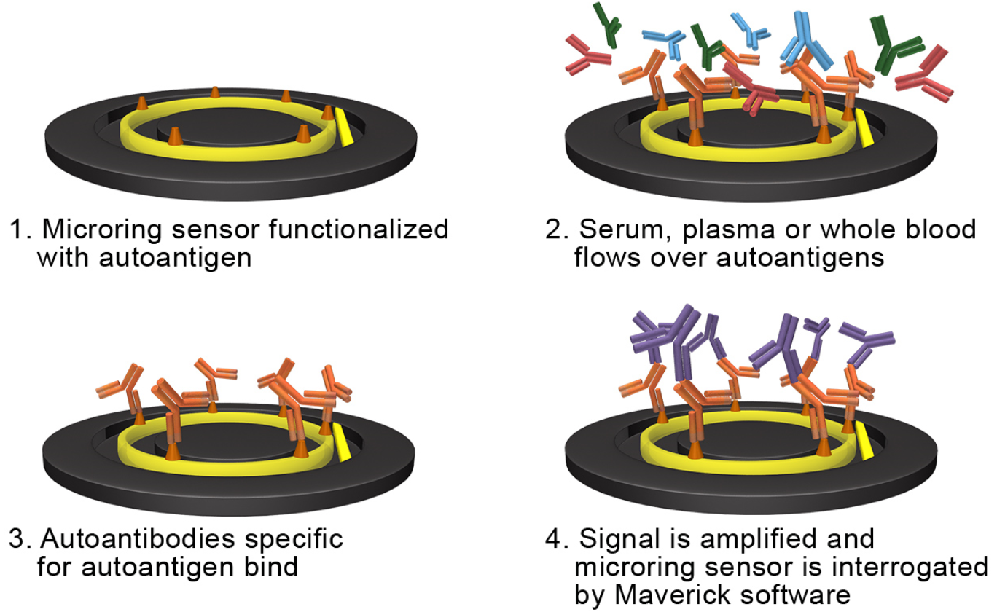
Figure 1: Maverick Detection Technique [12]
The constant monitoring of the effective index change enables real-time detection without the need for a tag, label, or reporter molecule. The results are available usually in 15 minutes depending on the type of assay performed.
Each sensor is placed next to the linear waveguide on the chip’s surface that directs light from a laser on to a photodetector. As light propagates in the straight waveguide each ring-resonator will trap a single wavelength, creating a peak in the wavelength spectrum received at the photodetector also called as FSR or Free-Spectral-Range. The collection of biological complexes on the sensor surface causes the effective index of the resonator to change, which in turn causes a longer wavelength of light to be trapped and the FSR to shift. The degree of shift of the FSR is directly proportional to the total mass of molecules per unit surface area. The figure below shows the approximate size of the glitch for different detections limits. Each chip contains almost 128 separate micro-ring resonators for multiplexed detection.
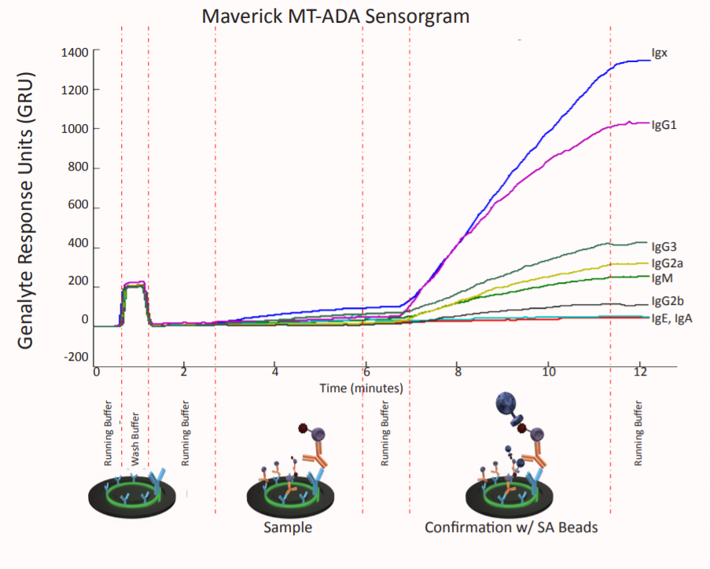
Figure 2: Maverick results plotted in picometers of wavelength shift over time - Genalyte Response Units (GRU)
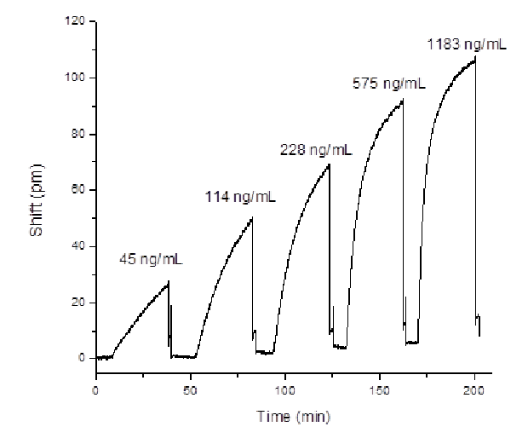
Figure 3: Maverick results plotted in picometers of wavelength shift over Detection Time
Genalyte announced the TE mark for their Maverick detection system in 2013.

Corning® Epic® Systems
Corning (Corning, New York, NY, USA) [13] came up with a label free detection equipment based on Resonant Waveguide Grating Biosensor System called Corning® Epic®. They have used a microarray which contains up to 384 wells for multiplexed detection. These are used to immobilize proteins, peptides, small molecules and DNA. After these molecules have been immobilized, a baseline test is established. Then the analyte is passed over the chip and once this is done the analyte material binds to these proteins and peptides. When the test is performed in comparison to the baseline it is observed that there is a change in wavelength of the reflected wave. Three second whole microplate read time [14].
- Immobilization step: This is the chemical conjugation of the receptor-containing protein to pre-activated plates.
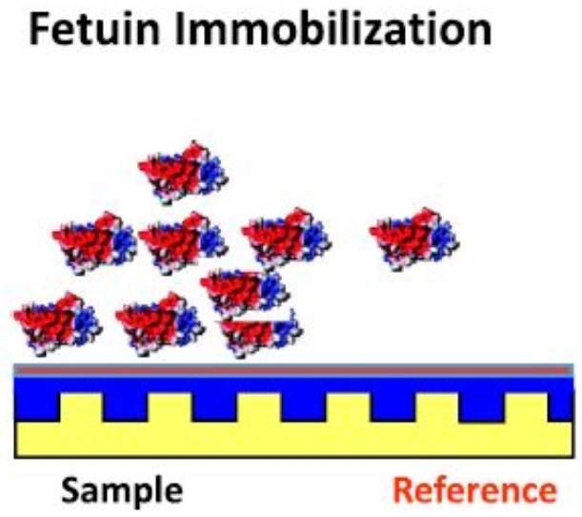
Figure 4: Immobilization step
- Wash step: Following the wash and equilibration on the molecule buffer, the chip is tested to establish a baseline reading.
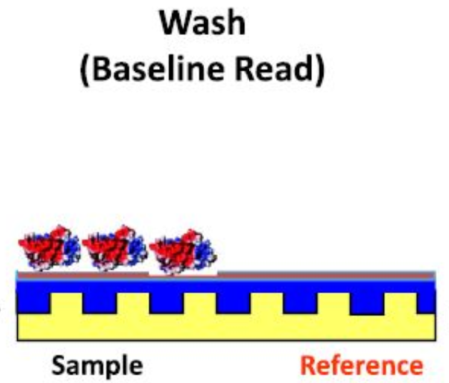
Figure 5: Wash step
- HA binding step: The ligand (rHA) is passed on the chip and the wavelength of reflected light is measured in the portion of the well containing immobilized protein. This is done using an internal control sensor located in a portion of the well that has no capacity to immobilize protein.
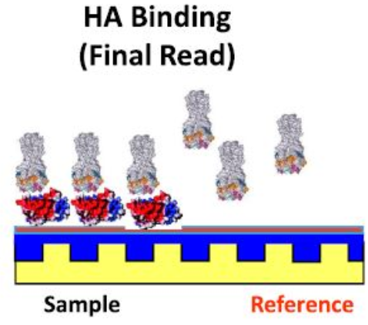
Figure 6: HA Binding step

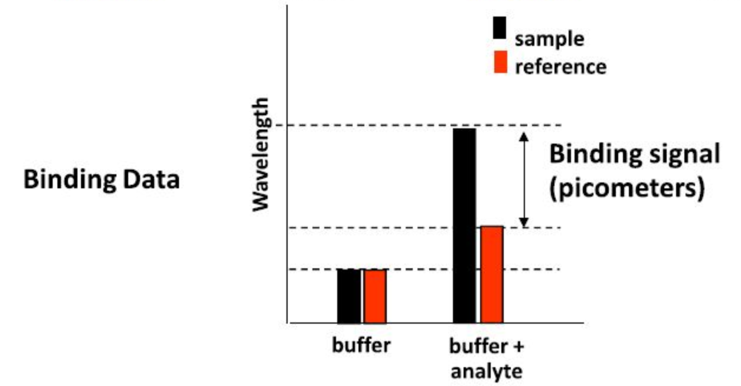
Figure 7: Shift in wavelength of Reflected wave in Epic Systems
There is need for highly sensitive counter-screening (Counter-screening is used to eliminate compounds that possess undesirable properties) across different targets within hit follow up to ensure potential lead compounds were more fully characterized prior to decisions regarding their progress.

Axela dotLab® mX Systems
The dotLab® mX System [16], is a highly flexible and easy to use assay platform appropriate for protein biomarker research and the investigation of new diagnostic tests. Diffractive Optics Technology or DOT combines multiplex immunoassay (a procedure for detecting or measuring specific proteins or other substances through their properties as antigens or antibodies) formats with real time measurements thereby giving more informative immunoassays compared to traditional end-point techniques.
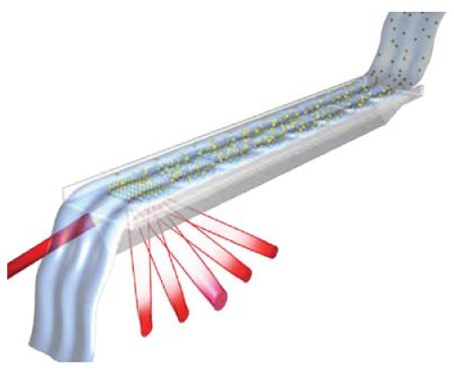
Figure 8: Axela dotLab® System
Diffractive optics technology brings together two technologies: grating-based light diffraction and immobilized capture surfaces [15]. This combination gives us a very easy-to-use and sensitive technique for the detection of molecular binding without the use of fluorescent labels. Capture molecules, such as antibodies, are immobilized in an ordered pattern of lines that form a diffraction grating on the surface of the dotLab® Sensor (prism shaped). When illuminated by a laser, a series of discrete diffraction beams is generated. When the sample is passed over the fiber gratings, the biomolecules, such as an antigen bind to the protein receptors, increasing the height of the surface pattern, producing a phase shift in the reflected beams. This in turn increases the diffraction signal intensity that is detected in real time by a photodiode detector below the sensor.
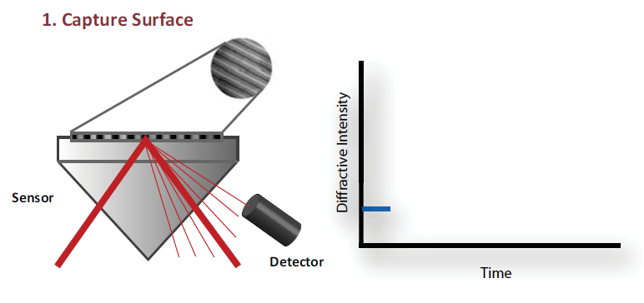
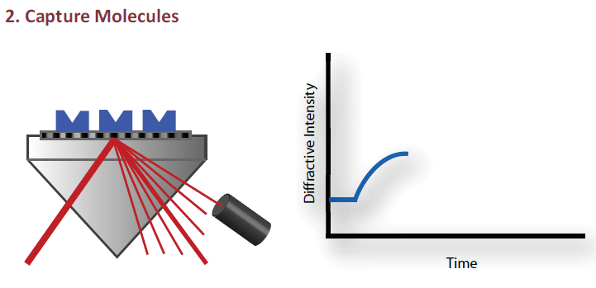
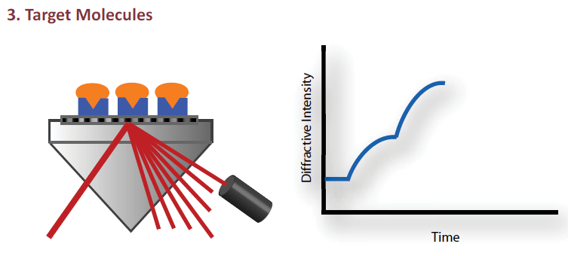
Figure 9: Diffractive Optics Technique
Results are obtained in less than an hour and an extremely small sample is required for testing (3.5μL of serum).

Project Objective
For the project we will be studying and researching the challenges faced by photonic biosensors. A few of these challenges have been aforementioned in section II. The most important of these challenges is the lack of availability of simulation tools and simulation models for liquid analyte testing. The main challenge here is to create a model for blood sample properties depending on analyte concentration and the temperature dependencies of these properties. To mitigate this challenge, we plan to survey existing works (if any) and comprehensively research methods that address this situation and if possible, provide our own insights for the same.
One common observation is that all these problems are a part of a bigger challenge which is implementing a full-fledged “Lab-on-Chip” module for commercial bio sensing applications. Most of the challenge mentioned in the previous section add to the obstacles towards creation and integration of a silicon photonic bio sensing Lab-on-Chip. Thus, our second objective is to exhaustively survey current efforts towards commercialization of photonic Bio sensing chips and Lab-on-Chip architectures and create an in-depth review of state-of-the-art commercial bio sensing packages.

Methodology and Colaboration Plan
For our project, we will be researching and surveying current journal papers and articles which address the Lab-on-Chip architectures and implementations. We will then review the common problems faced by these researchers in terms of large-scale manufacturing and commercialization. There are a few manufacturers with an existing commercial implementation of Lab-on-Chip modules. We would like to study these implementations and analyze if these implementations solve the common problems faced by other research teams.
Due to high fabrication costs, it becomes inevitable for designers to simulate the design results before proceeding to the next stage of fabrication. This holds true in bio sensing applications as well. As most of the bio sensing requirements are based on methods that use the analyte as a cladding material, it becomes crucial to model the optical properties of materials of interest. Thus, in our effort towards surveying this issue we plan to start with the variety of analytes that are currently used in bio sensing applications and analyze their respective optical models (if any). Upon finding these models or modelling strategies we intend to analyze and compare the correctness of the existing models. If we are unable to find any existing models, we would like to further investigate the main reason for the unavailability of these models and challenges in developing the same. And if time permits, we would like narrow down on one specific sensing application and create a model for the properties of the analyte material of interest.
Mihir Pakhale started with the review and survey of existing Lab-on-Chip architecture. He also reviewed the detection techniques and sensors required to design a full-fledged Lab-On-Chip architecture. Sumant Sakhalkar worked on the commercially available state-of-the-art Lab-on-Chip modules by various manufacturers, prepare a detailed analysis and compare the modules analyzed. Yash Chopra dealt with the need for simulation models and tools, review the existing work and compare the available models.
Sumant Sakhalkar also reviewed the necessary steps and challenges in creating a model and collaborated with Mihir and Yash to devise the selected analyte model.

References
- Kirill Zinoviev et al. , “Silicon Photonic Biosensors for Lab-on-a-Chip Applications”, Advances in Optical Technologies, vol. 08, Barcelona, Spain, 2008.
- Shon Schmidt, “Enhancing the performance of silicon photonic biosensors for clinical applications”, University of Washington, 2016.
- Estevez, M.C.; Alvarez, M.; Lechuga, L.M. “Integrated optical devices for lab-on-a-chip biosensing applications.” Laser Photon. Rev. 2012, 6, 463–487
- Adrián Fernández Gavela et al., “Last Advances in Silicon-Based Optical Biosensors”, Sensors, SP, Brazil, Feb 2016.
- Tanobe, H., Kondo, Y., Kadota, Y., Okamoto, K. and Yoshikuni, Y., “Temperature insensitive arrayed waveguide gratings on InP substrates,” IEEE Photonics Technology Letters 10(2), 235-237 (1998).
- L. M. Lechuga, “Optical biosensors,” in Biosensors and Modern Biospecific Analytical Techniques, L. Gorton, Ed., vol. 44 of Comprehensive Analytical Chemistry Series, pp. 209–250, Elsevier Science BV, Amsterdam, The Netherlands, 2005.
- B. Sepulveda, J. Sanchez del Rıo, M. Moreno, et al., “Optical biosensor microsystems based on the integration of highly sensitive Mach-Zehnder interferometer devices,” Journal of Optics A, vol. 8, no. 7, pp. S561–S566, 2006.
- Duval, D., Lechuga, L.M., “Optical Waveguide Biosensors. In Photonics: Scientific Foundations”, Technology and Applications, IV; Andrews, D.L., Ed.; John Wiley & Sons: Hoboken, NJ, USA, 2015; pp. 323–365.
- Kozma, P.; Kehl, F.; Ehrentreich-Förster, E.; Stamm, C.; Bier, F.F. “Integrated planar optical waveguide interferometer biosensors: A comparative review”, Biosens. Bioelectron. 2014, 58, 287–307.
- S. Talebi Fard, S. Schmidt, W. Shi, W. Wu, N. Jaeger, E. Kwok, D. Ratner, L.Chrostowski, ’Optimized Sensitivity of Silicon-on-Insulator Strip Waveguide Resonator Sensor’, Submitted, 2016.
- Genalyte Inc., “Maverick Detection System Assay Platform”, San Diego, CA, 2003, Available: https://www.genalyte.com/download/1547/.
- Adam L. Washburn, Matthew S. Luchansky, Melinda S. McClellan, Ryan C. Bailey, “Label-free, multiplexed biomolecular analysis using arrays of silicon photonic microring resonators”, Procedia Engineering, vol. 25, 2011, pp. 63-66.
- Resonant Waveguide Grating Biosensors for Living Cell Sensing. Fang, Y., Ferrie, A., and Fontaine, N., Mauro, J., Balakrishnan, J. Biophysical Journal. 2006.
- Label-Free Biosensors. Cunningham, B., Karlsson, R., Rich, R., Myszka, D., Markey, F., Huber, W., Fang, Y., Fang, J., Tran, E., Xie, X., Hallstrom, M., Frutos, A., Borwn, R., Brandts, M., O’Brien, R, Peters, W., McGuinness, R., Verdonk, E. (Cooper M, eds.), University of Cambridge Press. 2008.
- Pak BJ, Vasquez-Camargo F, Kalinichenko E, Chiodini PL, Nutman TB, Tanowitz HB, et al. (2014) Development of a Rapid Serological Assay for the Diagnosis of Strongyloidiasis Using a Novel Diffraction-Based Biosensor Technology.
- Adam Liederman, Carla Ring-Herron, Lahay Gil, Ray Cracauer and Oscar Nespoli, “dotLab® System Industrial Design”, Axela Inc., 2010.

